***Does the Food Industry Lead or Follow?***

*Grocery retailers are struggling to find the right balance between in-store and online shopping. Thin margins and high fixed costs don’t leave a lot of room for innovating the consumer experience. But competition and changing consumer habits will force many grocers to adapt. Having been part of the food industry in various roles, I wonder how the food industry will react to these changes; will it lead or will it follow?*

*The food industry needs to think about where the grocery experience is changing, because they share the customers whether they like it or not, and the healthier of their industry benefits the retail. Cynics might say that online grocery shopping only represents a very small percentage of total sales. But the demand for online shopping is growing and driven mainly by dual-income families, who value convenience, and millennials, who grew up online, and represent the next-generation of grocery shoppers. Instacart, a pure online retailer from the US, recently released some aggregate sales data of 3 million orders and doing some exploratory data analysis allows us to discover some interesting facts about the typical customer. For example, the most ordered department is produce.*

*Products being purchased together creates a connection between departments. By looking at the resulting network we see a highly centralized network showing that people do groceries for 4 reasons: produce (hortifruti), snacks, dairy&eggs or beverages. The closer the names in the picture more likely items are purchased together, like deli (fatiados) and alcohol.*

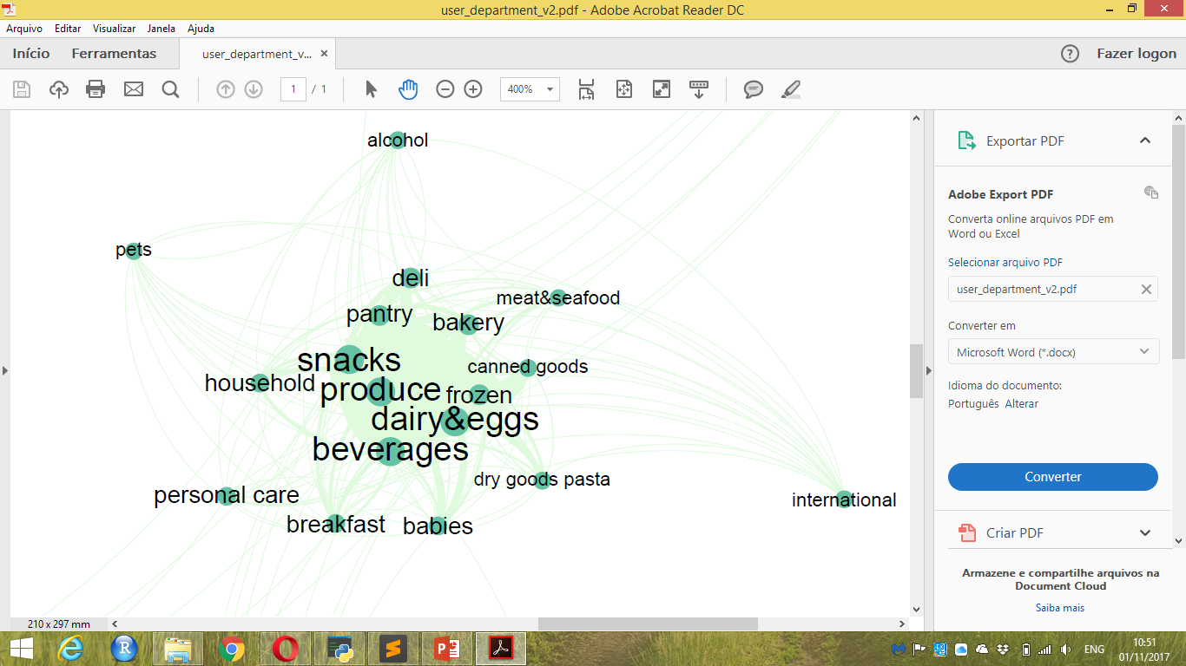

*There is a famous case study of a strong tie between diapers and beer, the story says that when fathers go to buy diapers they treat themselves beer. This shows that the food industry should look beyond its borders and closer to the consumer perspective. On this dataset what I found is that when a person buys bananas they also buy organic avocados. But when they buy plates they buy regular avocados. Which leads us to think that when a person buys for themselves in a regular basis they go for the healthier organic, but when they throw a party they save some money and get regular avocado for the guacamoles.*

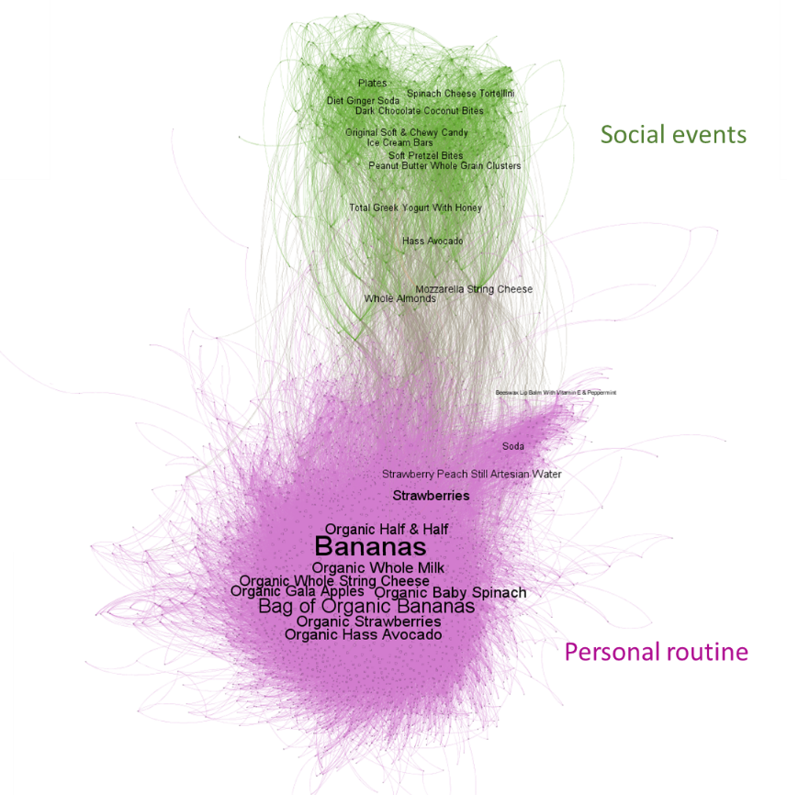

*It seems clear that the trends point to a mixture of online and in-store shopping. The good news for grocers and the food industry is that food-related engagement is high, people care more and more about health and what they put in their bodies, and cooking shows and how-to-videos and recipes are popular. The bad news is that customers are less willing to walk through ten aisles to find the right ingredients for dinner.*

*What the food industry and the grocery retailers need to do is re-introduce the joy of discovery. Display products according to a specific “dinner” allowing the customer to pick up all the ingredients at once. QR codes on products could link to how-to-videos showing how to prepare the meals. Allow people to order products online to pick up in store. Good food is important to our customers. The food industry should work with retailers to test multiple ideas, using real-time data, to find ideas that work. Doing this well requires creating teams with various abilities, from store operations to logistics to customer insights. But it is worth doing well. After all the future of grocery shopping is going to change. And as the saying goes, the best way to predict the future is to create it yourself.*

*You can get the code in my github account and here are some references for further reading. Best to all!*

*Instacart Customer Experience: http://www.thekitchn.com/i-had-my-groceries-delivered-by-instacart-and-heres-how-it-went-214795*

*Instacart Data: https://tech.instacart.com/3-million-instacart-orders-open-sourced-d40d29ead6f2*

*Instacar Website: https://www.instacart.com*

*Instacart Kaggle Competition: https://www.kaggle.com/c/instacart-market-basket-analysis*

*EDA inspirations: https://www.kaggle.com/sudalairajkumar/simple-exploration-notebook-instacart*

*https://www.kaggle.com/philippsp/exploratory-analysis-instacart*